**Brandon Kline**

**Database Systems Lab 9**

1. 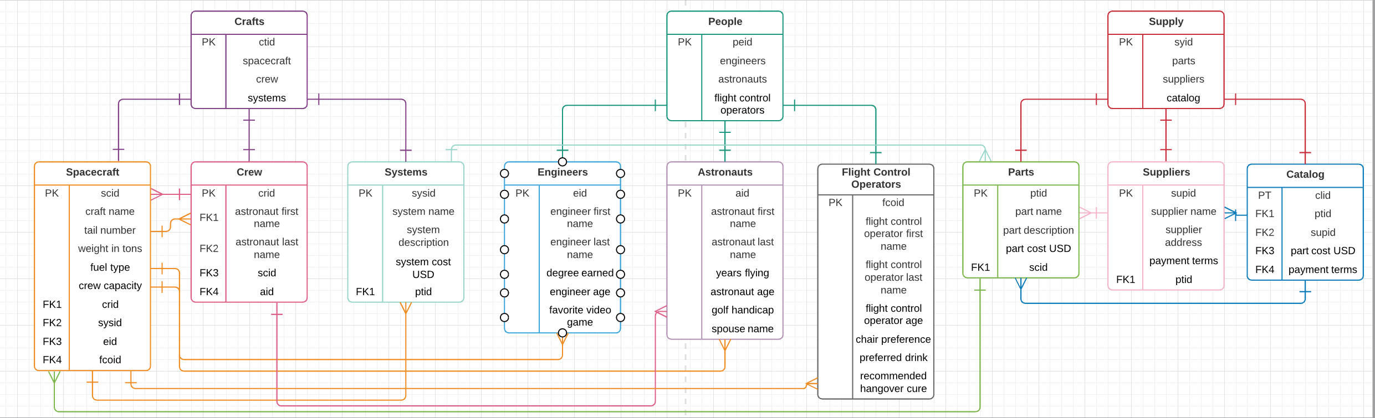
2. According to the tables in the database:

* Ctid → {Spacecraft, Crew, Systems}
* Peid → {Engineers, Astronauts, FlightControlOperators}
* Syid → {Parts, Suppliers. Catalog}
* Scid → {CraftName, WeightInTons, FuelType, CrewCapacity, Crid, Sysid, Fcoid}
* Crid → {AstronautFirstName, AstronautLastName, Scid, Aid}
* Sysid → {SystemName, SystemDescription, SystemCostUSD, Ptid}
* Eid → {EngineerFirstName, EngineerLastName, DegreeEarned, EngineerAge, FavoriteVideoGame}
* Aid → {AstronautFirstName, AstronautLastName, YearsFlying, AstronautAge, GolfHandicap, SpouseName}
* Fcoid → {FlightControlOperatorFirstName, FlightControlOperatorLastName, FlightControlOperatorAge, ChairPreference, PreferredDrink, RecommendedHangoverCure}
* Ptid → {PartName, PartDescription, PartCostUSD, Scid}
* Supid → {SupplierName, SupplierAddress, PaymentTerms, Ptid}
* Clid → {Ptid, Supid, PartCostUSD, PaymentTerms}

1. The database is indeed in third normal form, as every attribute for each table depends on the primary key, and only the primary key for that table. For example, the table Systems has a primary key of Sysid and attributes of SystemName, SystemDescription, and SystemCostUSD. SystemName cannot function as a candidate key, as two systems could have the same name (albeit unintentionally or due to human error). SystemDescription also fails to be a reliable candidate key, as two items could also have the same description. Finally, SystemCostUSD is a very poor choice for a candidate key as it is highly likely that at some point, two systems in a catalog will cost the same amount. Thus, all attributes within the table must rely on Sysid as a unique identifier, fulfilling third normal form.